PENNSYLVANIA PHYSICAL THERAPY ASSOCIATION

Course Title

Speaker: Speaker Name

Date of Course
Course Location

****CONTACT HOUR CERTIFICATE****

This will certify that

First Last

COMPLETED TOTAL NUMBER OF CONTACT HOURS: (specify # of general and/or evaluative hours)

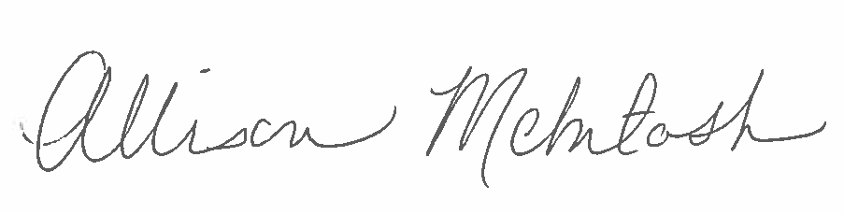

ALLISON McINTOSH, EXECUTIVE DIRECTOR

APTA/PPTA has received pre-approval provider status for all continuing education courses from the Pennsylvania State Board of Physical Therapy.

