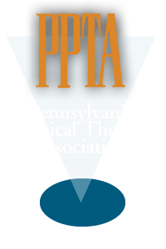
Northeast District Pennsylvania Physical Therapy Association
March 7, 2018

Dear Northeast District Member,
The Northeast District, in our commitment to facilitate professional involvement, has established 2 - $500 scholarships to APTA members to attend the Annual Pennsylvania Chapter Conference. Our goal is to promote and grow professional involvement within our professional organization and encourage participation in APTA/PPTA activities. The NED serves the counties of Susquehanna, Northampton, Wayne, Lehigh, Luzerne, Lackawanna, Wyoming, Monroe, Carbon, and Pike.
We are currently seeking applicants for this year’s PPTA conference to be held in Valley Forge, Pa in October 2018. Specifically we are hoping to award one scholarship to a new professional in the first 5 years of practice and one scholarship to a professional with 5+ years of experience. The scholarships are open to physical therapists and physical therapist assistants as long as they are an APTA member in good standing (Non-members may apply with the expectation that they will become a member if accepted for the scholarship)
If you are interested in attending an established CEU event that will promote networking and enhance your resume, along with a lot of fun with your fellow PPTA peers, please submit a Word Document expressing your interest, with an explanation on what you hope to gain from this experience. Submissions can be made to Laurie Brogan (lbrogan@misericordia.edu ) by Friday, August 24th. All submissions will be reviewed by an impartial committee and applicants will be notified of the board decision by September 5th. This is a great professional opportunity with many positive benefits. We are excited to offer an APTA benefit encouraging new exposure and participation in a long-standing chapter event.

Laurie Brogan, PT, DPT, CEEAA, GCS

Chair NED PPTA

