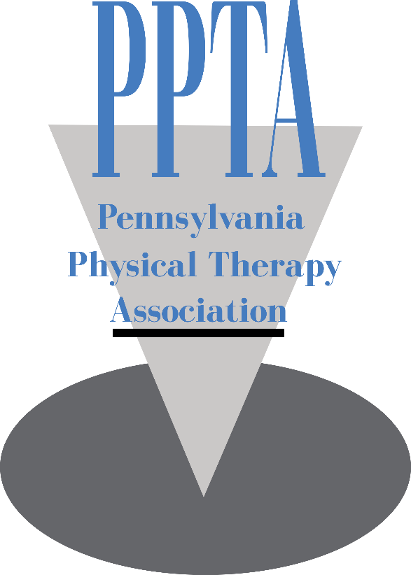

Photo/Video Release Form for Minors (if under 18)

The Pennsylvania Physical Therapy Association (PPTA) has my permission to use my or my child’s photography or videography publicly in promotions and within on-site displays. I understand that the images and videos may be used in print publications, online publications, presentations, websites, social media and general display. I also understand that no royalty, fee or other compensation shall become payable to me by reason of such use.

Parent/Guardian’s signature: ________________________________Date________

Parent/Guardian’s Name: ______________________________________________

Child’s Name: ______________________________________________________

Phone Number: _____________________________________________________

